Primary Five Information Sheet.
Welcome to Primary Five. We hope your child has settled into their new class. This year we would like each child to have a pencil case with a number of sharpened pencils, a rubber, a sharpener, a small glue stick and coloured pencils so as to encourage independence and responsibility for belongings.
We would also ask each child to bring a box of tissues for use in the classroom.
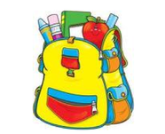
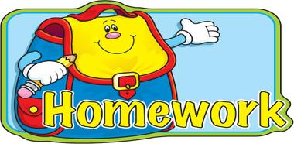

Children complete a written homework each night. Homeworks will alternate between Literacy and Numeracy with some exceptions to include other areas of the curriculum, when appropriate, to reinforce classwork.
All homeworks should be signed by a parent or guardian.
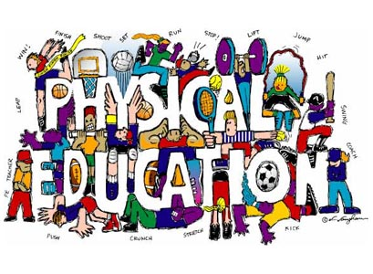

Children need a P.E Kit- a white t-shirt, navy shorts and P.E slippers. All items should be named and brought to school as soon as possible. Girls with long hair should have it tied back. No earrings should be worn during P.E.
I hope you find the information on this sheet helpful.
Many Thanks
H. Hughes
D. Lynch
K. Davison / A. McArthur

